

|  |  |  |
| --- | --- | --- |
| **Serial No.** | **Details** | **Page No.** |
|  |  |  |
| 1 | Table of Contents | 2 |
| 2 | Employee | 4 |
|  | 1. Upload Employee Details | 4 |
|  | 1. Create Employee | 4 |
|  | 1. View/Edit Employee | 5 |
|  | 1. View Employee | 5 |
|  | 1. View Resigned Employee | 5 |
|  | 1. EDB Report | 6 |
| 3 | Leave & Attendance | 7 |
|  | 1. Leave Master | 7 |
|  | 1. Leave Rule | 7 |
|  | 1. Employee Leave Profile | 7 |
|  | 1. Holiday Master | 8 |
|  | 1. HR Leave Activities | 8 |
|  | 1. HR Attendance Activity | 8 |
|  | 1. Leave Reports | 9 |
|  | 1. Attendance Reports | 9 |
|  | 1. Leave Application | 9 |
|  | 1. Leave Status | 10 |
|  | 1. Approve Leaves | 10 |
| 4 | Travel | 11 |
|  | 1. Travel Masters | 11 |
|  | 1. Travel Request And Status | 11 |
|  | 1. Approve Travel Request | 11 |
|  | 1. Expense Request and Status | 14 |
|  | 1. Approve Expense Request | 15 |
| 5 | Reimbursement | 18 |
|  | 1. Reimbursement Master | 18 |
|  | 1. Reimbursement and Status | 18 |
|  | 1. Approve Reimbursement Request | 19 |
|  | 1. HR Reimbursement Request | 20 |
|  | 1. Accounts Reimbursement Activity | 20 |
| 6 | Appraisal | 22 |
|  | 1. Appraisal Master | 22 |
|  | 1. Appraisal Self Assessment | 24 |
|  | 1. Appraisal HR Menu | 25 |
|  | 1. Appraisal Line Manager Menu | 26 |
|  | 1. Appraisal Business Head Menu | 28 |
|  | 1. Increment Process | 29 |
|  | 1. All Appraisal Status | 30 |
| 7 | Recruitment | 31 |
|  | 1. Recruitment Master | 31 |
|  | 1. Requisition Form | 31 |
|  | 1. Approve RRF | 31 |
|  | 1. HR Activities- Recruitment | 32 |
|  | 1. Interview Rating –Round 3 | 34 |
| 8. | OnBoarding | 35 |
|  | 1. OnBoarding Forms | 35 |
|  | 1. Statutory Forms | 36 |
|  | 1. New Employee Creation | 36 |
| 9 | Exit | 37 |
|  | 1. Resignation | 37 |
|  | 1. Approve Resignation | 37 |
|  | 1. Exit Process | 38 |
|  | 1. Exit Clearance | 39 |
|  | 1. Resigned List | 39 |
|  | 1. Download List | 39 |

**Employee:**

**1. Upload Employee Details:**

* Employee details can be uploaded here by uploading the excel file which should contains all the necessary information those are mandatory.
* The upload format can be found by clicking on .
* If anything went wrong at the time of uploading warning will appear.

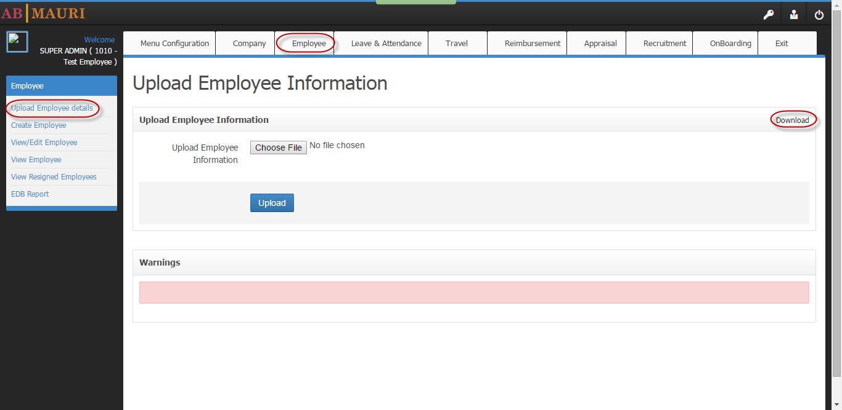

**2. Create Employee:**

* Employee profile can be created individually by providing all the necessary information of the employee along with a unique Employee code.
* For this process several information are required like i. Job details

ii. Approver details

iii. Contact details

iv. Professional details

v. Personal Details

vi. Employee Upload Details

* After completing the filling process and saving all the details, it can get submitted by clicking on Submit on final page.
* Whenever an employee profile is created the password for his login is “**abmauri**” which is default for all new profile. For the first time when the employee will log in to his profile he will ask to set a new password.

**3. View/Edit Employee:**

* The employee profiles which are created previously can be seen in this tab.
* The details of any employee can also be edited over here except the Employee code.
* Password can be reset for any employee by clicking on **Reset** situated on the right most side of the page.
* This tab will be given to **HR** and **Super** **Admin**.

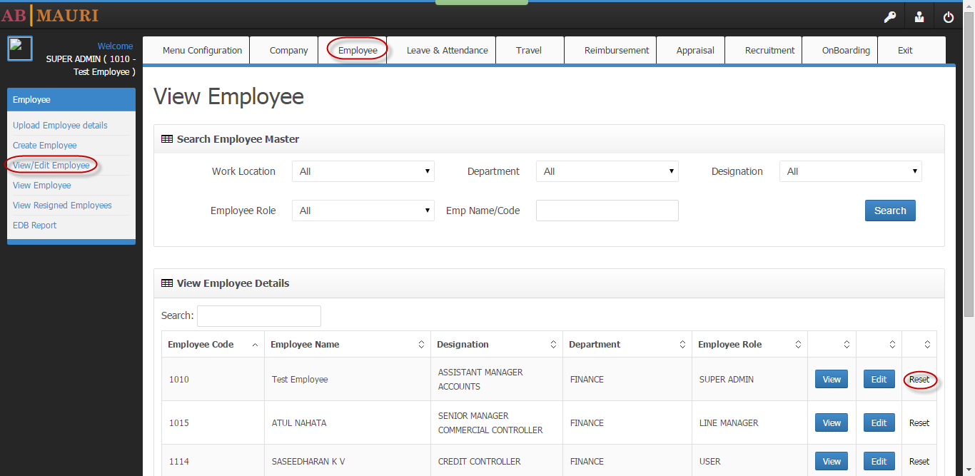

**4. View Employee:** This tab will be given to the employee in which they can just view the details but there is no option for edit.

**5.** **View resigned Employee:**

* The details all the resigned employee can be seen over here.
* To make an employee status as resigned HR needs to go to **View/Edit Employee ,**search for the employee profile ,click on the employee status dropdown and select resigned followed by the submit button. The above process is shown in the below image.
* Once the status is changed the employee profile will no longer can be seen in **View/Edit Employee.**
* It will be pushed to **View resigned employee**.

6. **EDB Report:** All the details of employee can be generate here.

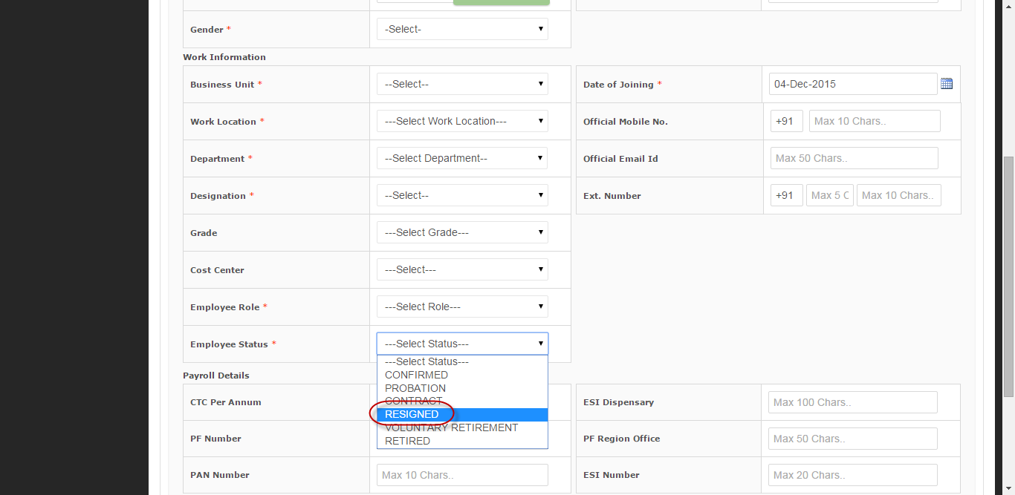

**Leave & Attendance:**

1. First **Leave policy** has to be created for different set of employees.

2. In **leave master** different kind of leave can be created.

3. Rules for these leaves can be created in **Create leave rule** by selecting the policy and leave name from the drop down.

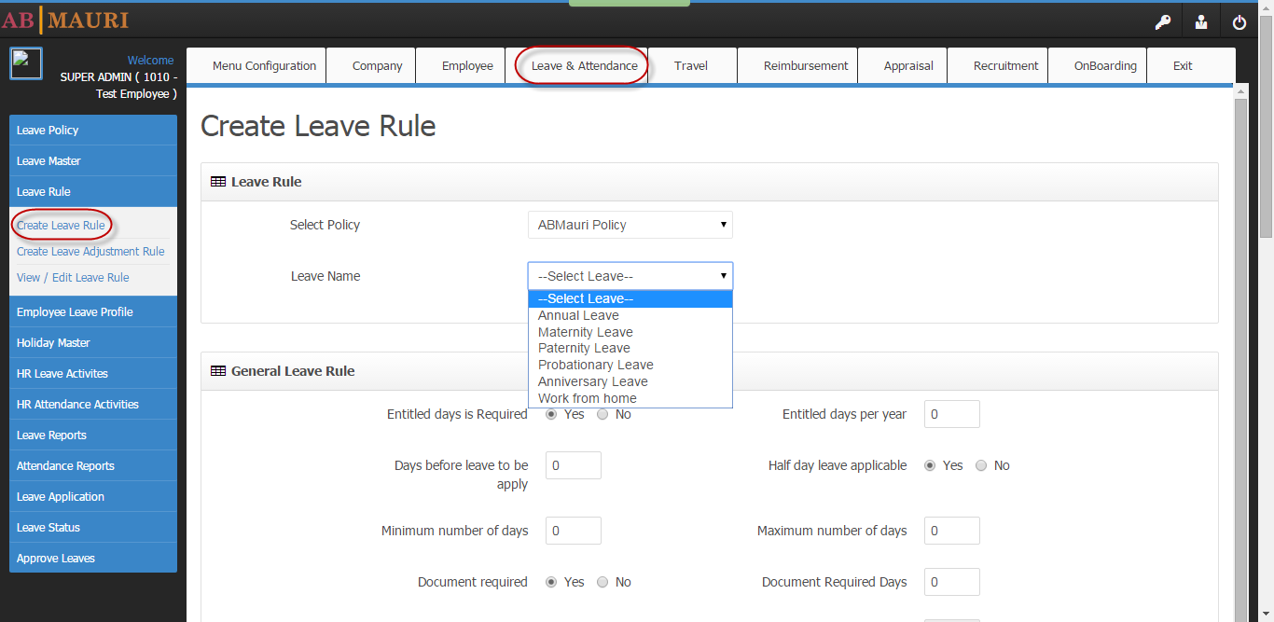

In this part different leave type can be defined for different policies and rules can be set.

4. When there is no balance left for a particular type of leave but still leave is applied, from which leave type it will get adjusted is defined in Adjustment rule. It can be created in **Create** **Leave adjustment Rule**.

5. For future aspect leave rule can be edited in **View and Edit leave rule**.

6. The most important job is to assign the Leave policy to all the employees. For that Leave profile has to be created for each employee **Create Employee Profile** which is present in **Employee Leave Profile.**

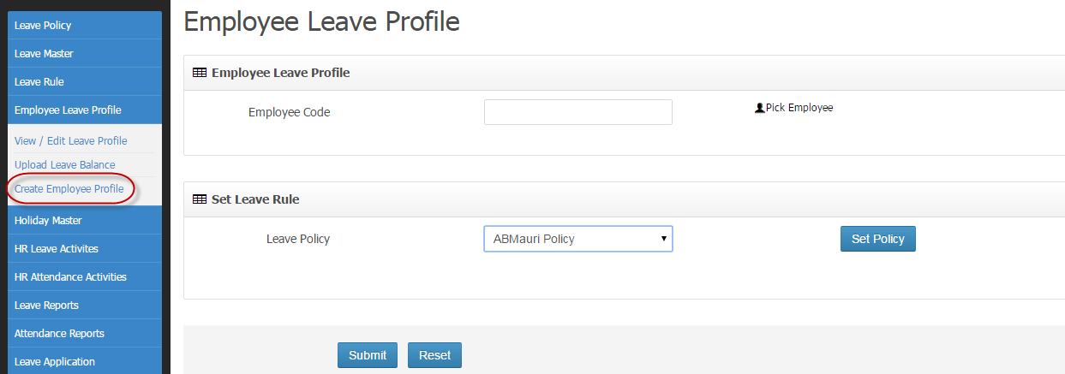

Here first Employee has to be chosen by clicking on  .Then from Leave policy drop down required policy can be selected and it will be assigned by clicking on  followed by Submit button.

7. So now leave profile can be seen and edited in **View and Edit Leave Profile.**

8. Uploading leave policy for set of employees can be done in **Upload Leave Balance**.

The sample file for upload can be downloaded by clicking on .So by filling the form in reference with the upload format and selecting the same file by clicking **Choose file** followed by clicking on Upload will update all the employees with their respective leave profile.

9. In **Holiday Master** holiday for each year can be assigned and the same will reflect in Leave application and attendance.

10. **HR Leave Activity**

i) **Assign Proxy Approver**: In case any leave application will be pending for 2 days for approval in approver’s login the same will be redirected to HR’s login and he needs to assign an approver for the same. And after assigning the application will get forwarded to the Proxy approver.

ii) **Leave Apply and Approve by HR:** HereHR can apply and update leave application on behalf of employee.

iii) **OD** **Apply and Approve by HR:** Here HR can apply for OD on behalf of employee.

iv)**Process Leave:** This is a monthly process done by HR where all the leave which were applied and approved for each employee will be reflected in their attendance.

11.**HR Attendance Activity:**

i) **Process Attendance**: This process will be done after downloading the attendance from biometric. The downloaded attendance has punched log detailsof each employee. After downloading the logs, the date range has to be selected. In reference to the log when process attendance button will be clicked the status will be assigned to the attendance register of the employee as present or absent.

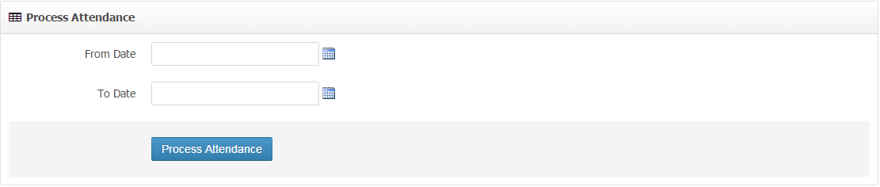

ii) **Overwrite Attendance:** Attendance which are already processed can be overwritten here.

12. **Leave Reports:**

i)**Employee Leave Balance:** Employee leave balance can be searched by following the below process .

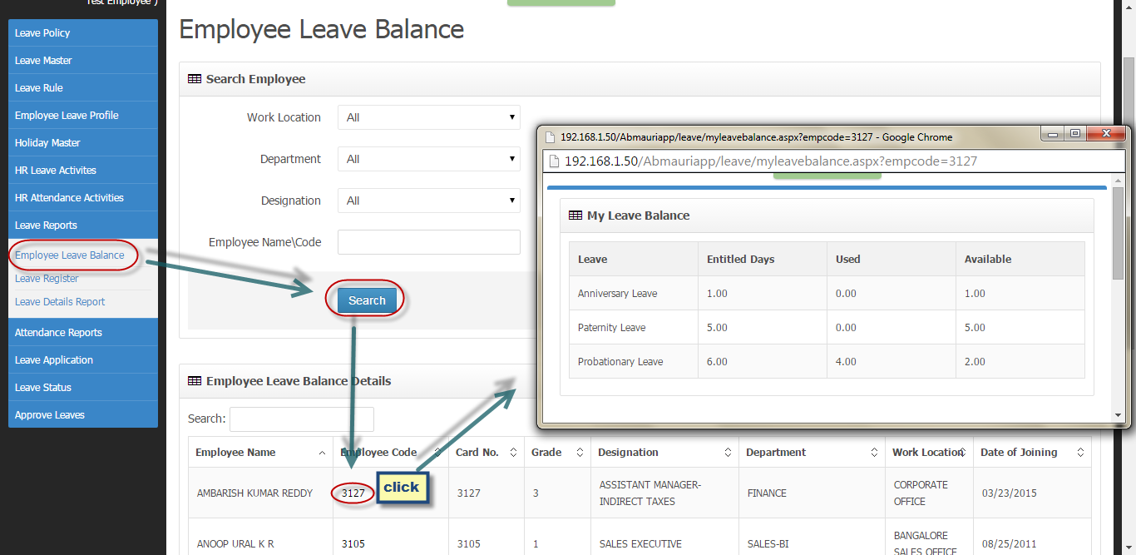

ii) **Leave Register:** Here leave log record can be found of different status like pending, approved, cancelled and rejected.

iii) **Leave Details Report:** All the details regarding leave can be extracted here by providing the time period and Employee details.

13. **Attendance report:**

i) **Monthly Attendance Report:** Here month wise attendance report can be fetched.

ii) **Employee wise Attendance:** Attendance for each employee can be fetched over here.

iii) **Date wise Attendance:** Report of attendance for each day can be generated here.

14. **Leave Application:**

i) **Apply Leave:**

* Leave can be applied only if leave police is assigned to that employee.
* After that the Employee can be able to view the balance leave and he will get the option of selecting leave type from drop down as shown in below image.
* By selecting the time period for leave and clicking on Calculate no of days, the system will search whether the number of days is available for that employee or not.
* After this by clicking the submit button leave can be applied.

ii) **Apply OD/WFH:**

* For **OD** and **work from home** same process will follow**.**
* There are few conditions in which OD can’t be apply like if leave is applied, employee can’t be able to apply for OD for that period.

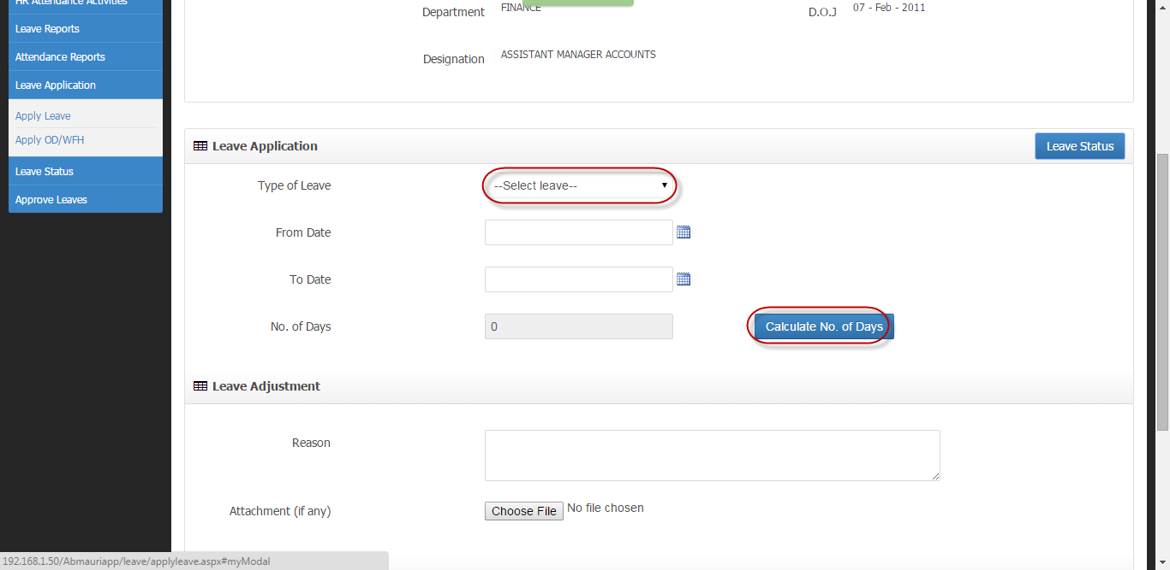

15. **Leave Status:**

i) **Pending Leave:**

* Once any employee will apply for leave application will be stays in this tab**.**
* Until and unless the application get approved it will stays here.
* In this mean time Employee can update or delete the application.
* Once the application is got cancelled it can’t be resubmitted.

ii) **Approved Leave:**

* By the time approver will approve for the leave request the application will move here.
* In this case employee can change the date for the leave application and can cancel it.
* But in case of changing the application will again go for approval and moved to pending Leave.

iii) **Canceled Leave:** In any state of time before availing the leave if the employee will cancel the application it will move here.

iv) **Rejected Leave:** If the application is rejected by the approver it will move to this tab and this case employee can’t be able to re submit the same form. A new leave application has to be sent.

16. **Approve Leave:** Approval for leave and OD can be done from here by line manager or proxy approver.

**Travel:**

1. **Travel Master:** It contains all the master data which can be useful in the travel process**.**
2. **Travel Request And Status:**
3. **Create Travel Form:**

* This menu will be available for all the employees.
* Employee needs to fill all the details followed by clicking on as shown below.

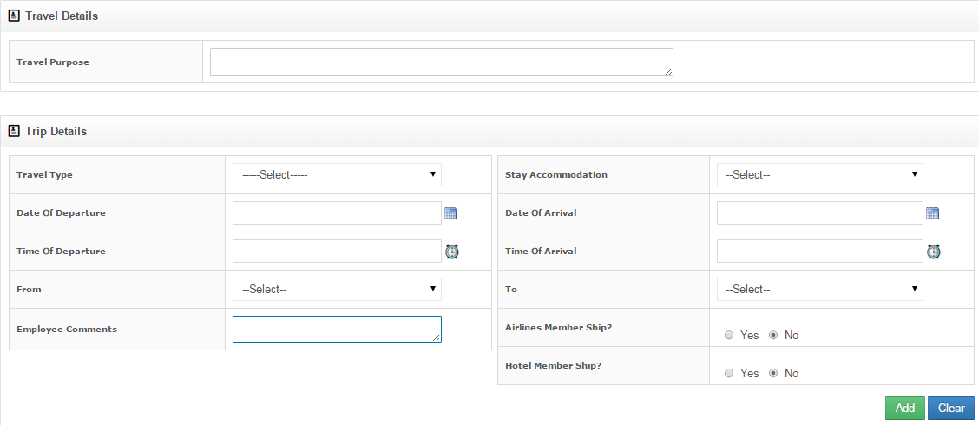

* Some privilege allowance option is given in the same form as below**.**

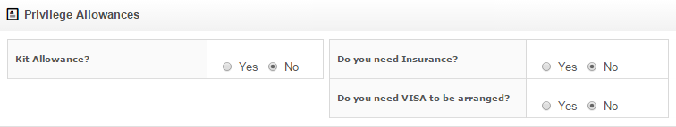

* After completing the form followed by clicking Submit form it will move to approver’s menu for approval.

1. **Approve Travel Form:** If the form will approved by all the approvers it can be seen in this tab.
2. **Pending Travel Form:** As soon as form is submitted for approval it can be seen in this tab until it will be approved by all the approvers or rejected by any of them.
3. **Rejected Travel Form:** In approval process if the form will rejected by any of the approver it will come to this tab.
4. **Approve Travel Request:**

**The most important point for this menu is there are two types of travel form**

1. **Domestic**
2. **International**

**So for domestic travel type there are three approvers Manager->Admin->Finance SPOC**

**But for International travel type the system will send the application to MD also for approval and the order of approval will be Manager->MD->Admin->Finance SPOC. The flow for this process is shown below.**

**For domestic**

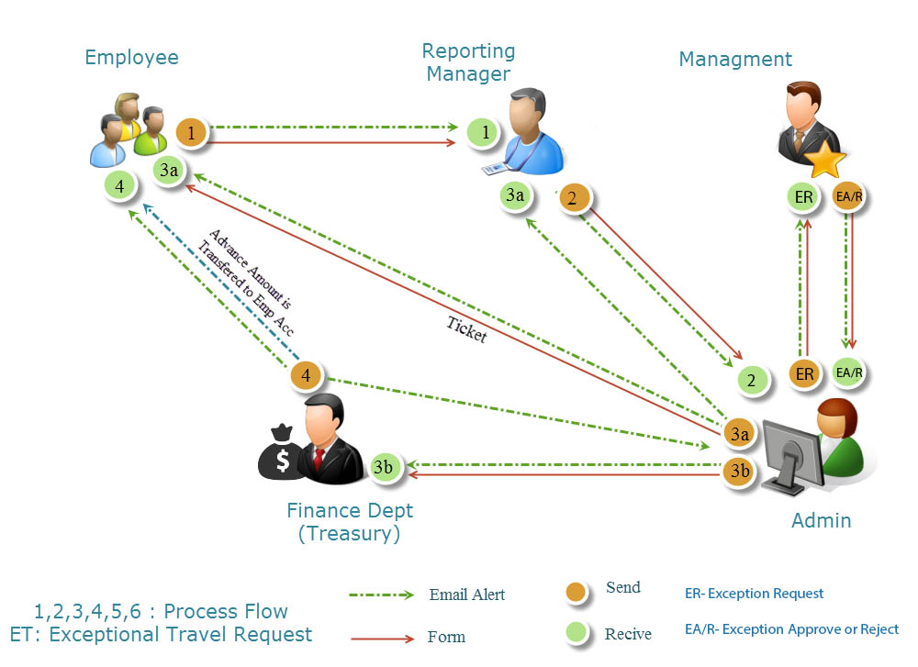

**For International**

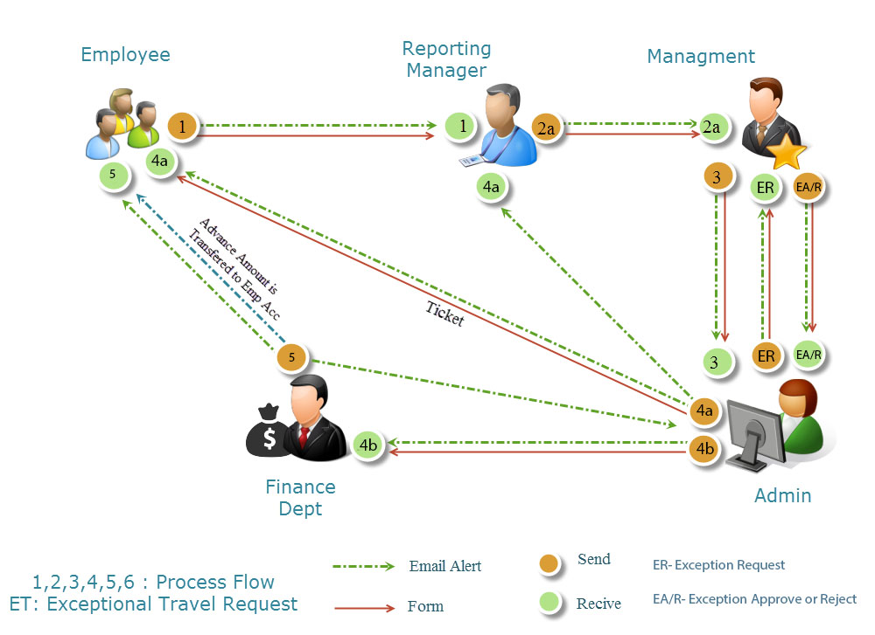

1. **Approve As Manager:**

* First the form will go to Line manager login for approval and he will get a menu as shown below.
* Manager needs to click on view to approve or reject the travel form.
* After the approval the form will move to admin’s approver.

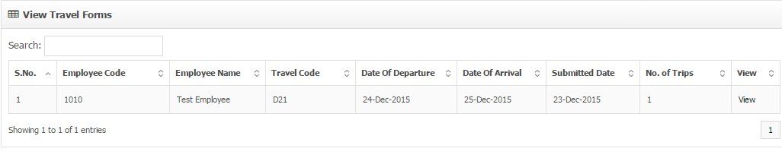

1. **Approve as MD**

* If the travel type is International then only application will come to this tab for MD approval.
* Otherwise it will move to Admin directly.

1. **Approve As Admin:**

* After Line manager approval the form will push to this tab.
* Admin can view the form and he has to do the ticket booking part if it’s not done by employee. For that he has to click on view/Edit as shown in the below image.

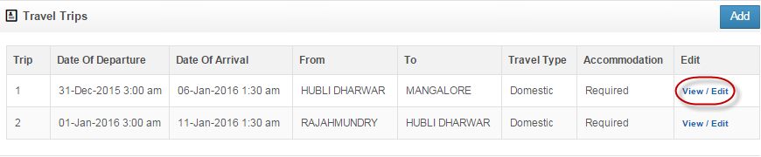

* After clicking the user will be redirected to a new window as shown below.
* User has to check the **Yes checkbox** and the following form will be visible
* After choosing Tier, Mode and class Admin has to select the currency type and enter the exact fare for ticket in the **Fare** textbox.
* He has to upload the ticket in Ticket upload option by clicking on Choose file and select the ticket file followed by clicking on  .
* Admin can also book the lodge in the below section if employee will ask for it in travel form as **Required** in **Stay Accommodation**.
* For that also Admin has to check the **Yes checkbox** and he can add the details.
* In the end he has to click on Update.

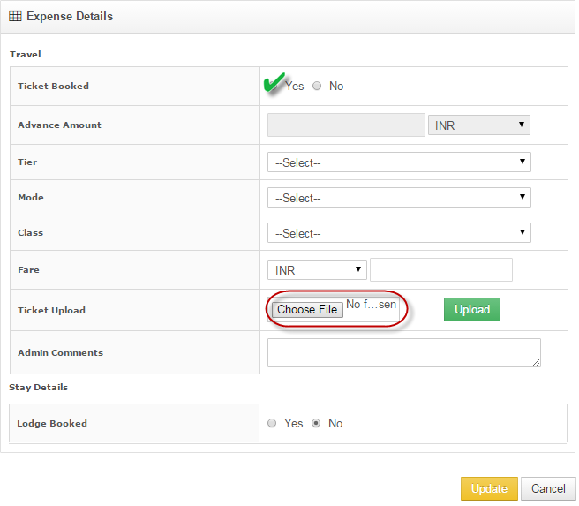

* After booking the ticket Admin can approve Pre travel advance as shown in below image.

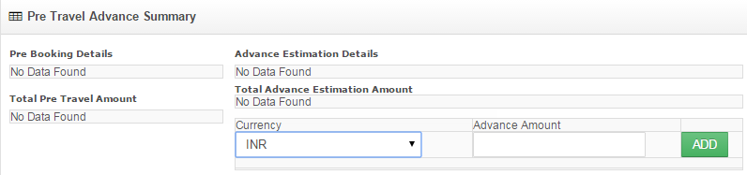

* He has to choose the currency and provide the advance amount in the box followed by clicking on Add
* Finally he can give his comment and click on approve, and the form will move to Finance SPOC approval.

1. **Approve as Finance SPOC:**

* The amount approved by the Admin, after transferring the same to the employee Finance SPOC has to update the status by clicking on  **.**
* This is the end of Travel approval process.

1. **Expense Request and Status:**
2. **Add Expense Details:**

* All the expenses in Travel can be added here.
* There are in total 6 different kind of expenses can added here those are

1. Travel
2. L & C (Stay)
3. OOP
4. Miscellaneous
5. Personal Car
6. Telephone/Fax

* After completing each detail user has to click add and finally after adding has to click on submit.
* Now the form will move for approval.

1. **Approved Expense:**

If the expenses are approved by all the approvers it can be seen here.

1. **Pending Expenses:**

Until and unless the expense application will approved by all the approver or rejected by any of them it will stay here.

1. **Rejected Expenses:**

If the form is rejected in any stage of approval it can be seen here.

1. **Approve Expense Request:**

**As there are two type of travel Form and for both different flow is given.**

**For Domestic**

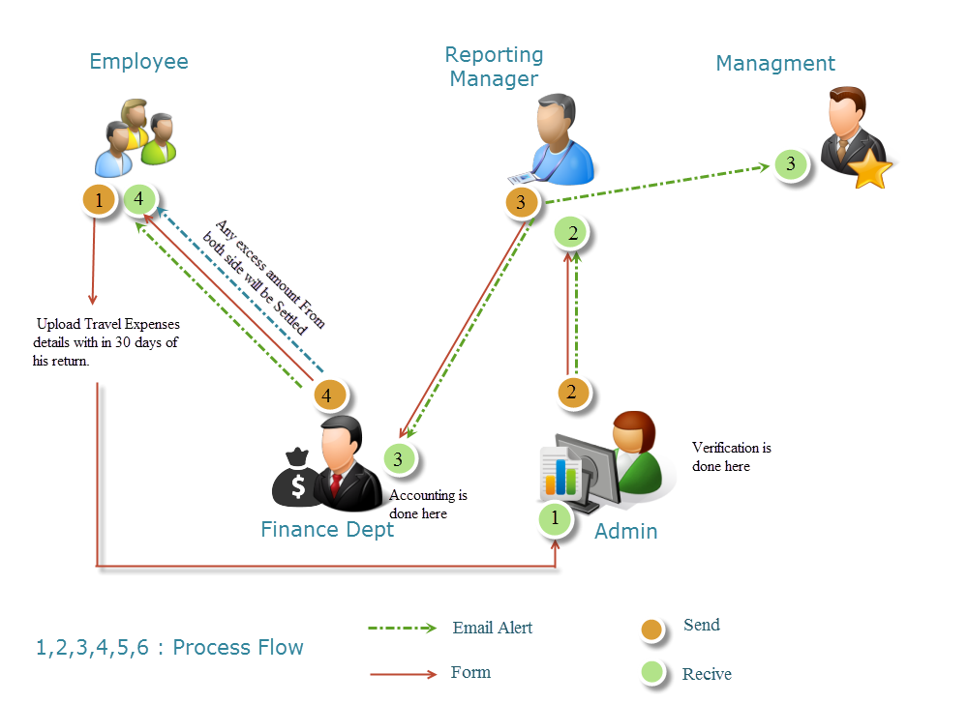

**For International**

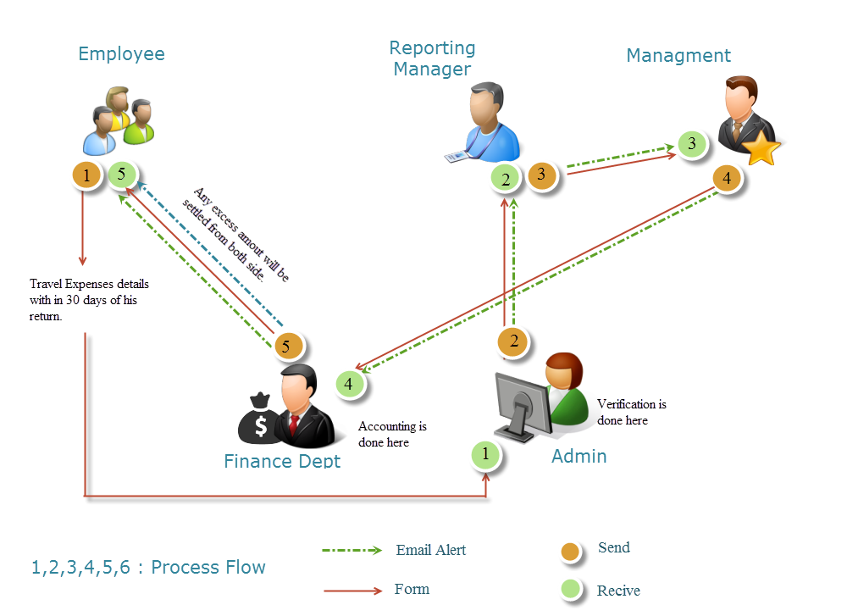

1. **Approve as Admin: +**

* First the form will come to Admin.
* Here he can review it and by clicking on View/Edit in trip details he will be redirected to a new window, in which all the expense details are mentioned.

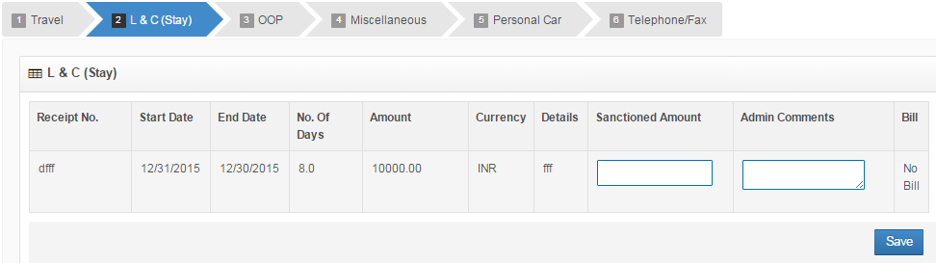

* He has given the option to add the sanctioned amount on the basis of Amount mentioned by the employee and can add comment followed by clicking on save.
* After clicking on save it will reflect in the Travel Expanse page and now he needs to click on approve to send the form to Manager.

1. **Approve As Manager:**

Manager can view the details and he has to approve the form by clicking on Approve and the form will move to **Finance SPOC** for further updation.

1. **Approve as Finance SPOC:**

He can view the summery and after providing comment has to click on  and auto generated confirmation mail will be sent to employee.

This is the end of the Travel process.

1. **Travel Report:**

Travel report can be generate here.

1. **Travel History:**

At any point of time all the information regarding travel application can be seen here.

**Reimbursement:**

**1. Reimbursement Masters:**

**Create Payhead:**

* For further Reimbursement process first payhead has to be created.
* Reimbursement are mainly of two types

i)Business Reimbursement

ii)Miscellaneous Reimbursement

* Based on these two all payheads has to be created as shown in the below image.

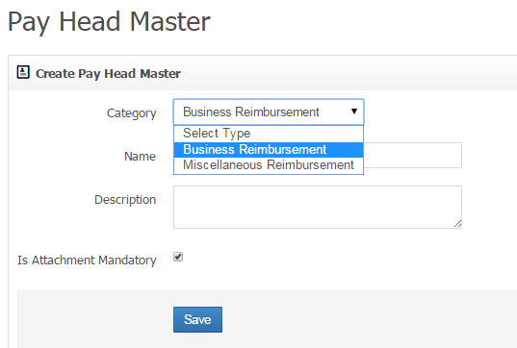

**2. Reimbursement and Status:**

**I) Create Reimbursement Request:**

* Here first employee has to fix the category tab.

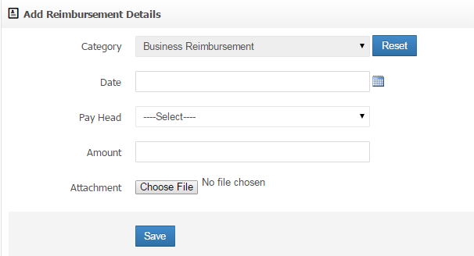

* When the category is fixed, related payheads for the same category will visible in payhead.
* If Employee needs to change the category, the Reset button has to be clicked.
* In payhead if attachment is made as mandatory than employee has to upload attachment, without which system will not allow to complete the process.
* After filling the form first system will ask to save it for verification.
* If updation is required than the particular form can be deleted and can add a new one, otherwise can submit the form for approval.

**II) Reimbursement Status:** all the status about reimbursement can be seen here by providing the date range.

**III) Closed Reimbursement: All** the reimbursement those are already closed can be seen over here.

**3. Approve Reimbursement Request:**

**i)Approved Reimbursement As Manager:**

* Here manager will get a tab as shown below.

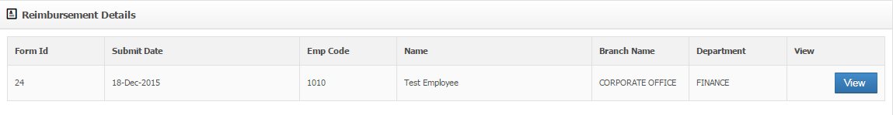

* By clicking on submit the page will redirect to a new pop up window which will provide all the details about the reimbursement as shown below.

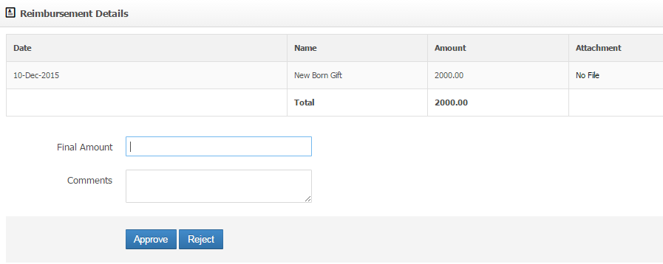

* Manager needs to enter the amount as per his preferences by writing some comments followed by clicking on Approve.
* If the request is not acceptable he can also reject it.

**ii) Reimbursement Inprocess:** The Form which is in process can be seen over here.

**Iii) Approved Reimbursement:** The form which is approved can be seen over here.

**4.HR Reimbursement Activity:**

**i) Pending Reimbursement:** The Form which are pending for HR approvalcan be seen here.

**ii) Reimbursement Status:** All the status for reimbursement can be seen here.

**iii)Closed Reimbursement:** The form which are closed from HR side can be seen here.

**iv)Reimbursement Report:** Reports for reimbursement can be generated here.

**5.Accounts Reimbursement Activity:**

**i)Pending Reimbursement:**

* When manager will approve the reimbursement form it will come to this tab for Account updation.
* For that Account manager needs to click on View as shown in the image below.

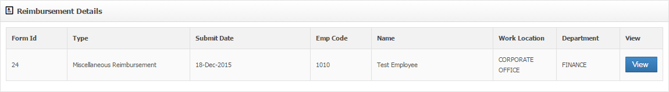

* When clicking on View a new pop up window will appear in which there is no edit or reject option.
* The amount which is approved by Manager that has to upload in the account as shown in the below image..

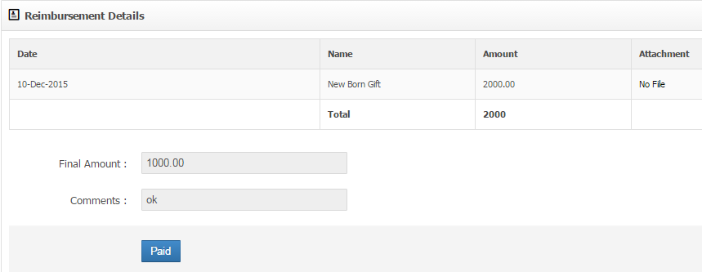

**ii) Reimbursement Status:** When the form is in process the status can be seen here.

**iii)Closed Reimbursement:** After clicking on Paid in Pending Reimbursement the form can be seen here.

**Appraisal:**

**1. Appraisal Master:**

**i)Set Appraisal Cycle:** This is the very first step for the appraisal process. Here HR needs to set the cycle for Appraisal for the current year.

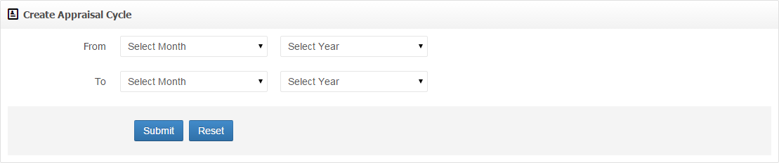

After selecting the cycle for current year followed by clicking on submit button the following tab will appear.

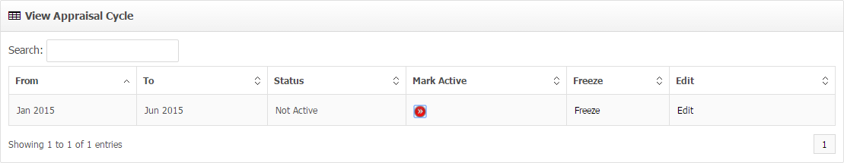

So to start the appraisal process for any particular cycle, HR has to make the status as Active by clicking on the red mark below **Mark Activity** column.

ii) **Select Eligible Employee:**

* The eligible employee for that cycle will come automatically in this tab.

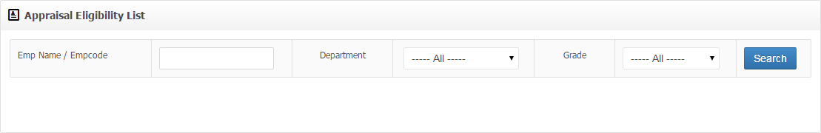

* Eligible employee can also be selected by selecting Department and Grade from the dropdown followed by clicking Search.
* After getting the eligible Employee list, the preferred employee can be selected by clicking on the check box next to employee details followed by clicking the “>” key to send it to selected list.
* Again there will be a check box next to the selected employee which needs to select before clicking **Save** as shown in the below image**.**

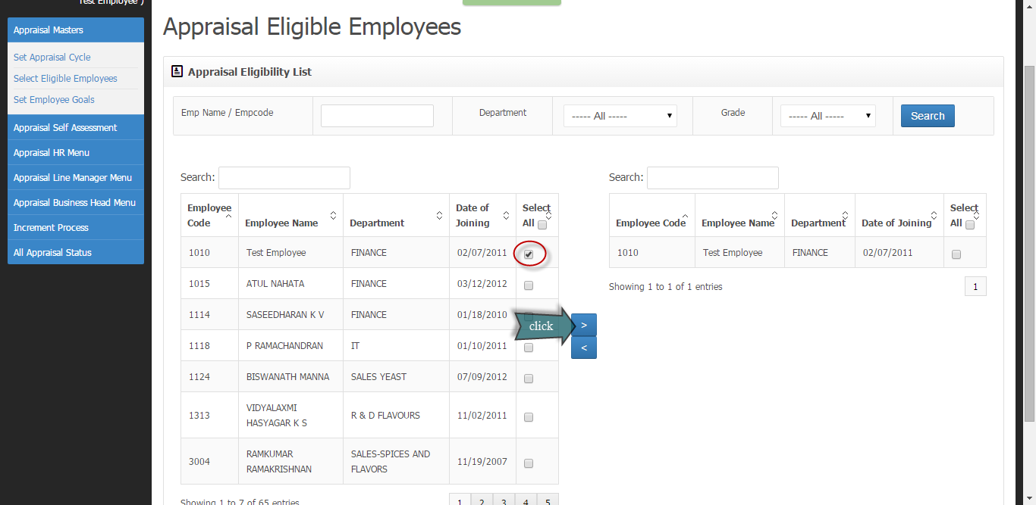

iii) **Set Employee Goals:**

* The employee who is selected from **Select Eligible Employee** can be seen here.

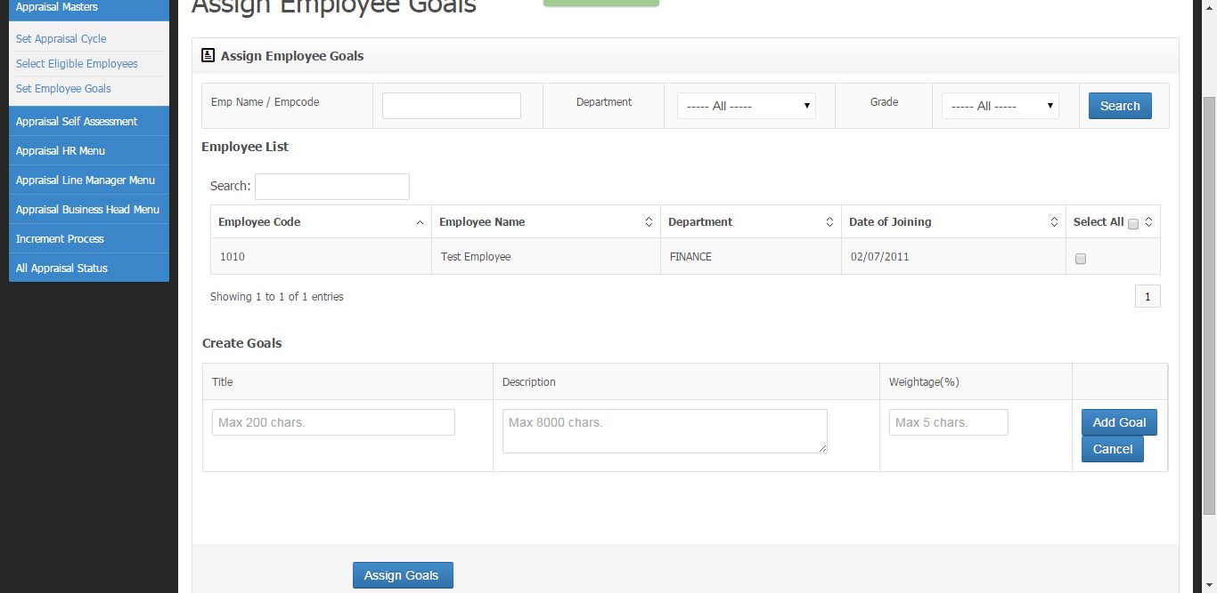

* HR needs to create goals by providing the details with the weightage for the set of employee.
* Here more than one goal can be added but the sum of weightage must be less than or equal to hundred
* Finally after adding all the goals HR needs to click assign goal and the goals will be assigned to each of the selected employee which can be seen in **Add/Edit goals** in Appraisal Self assessment in the employee login.

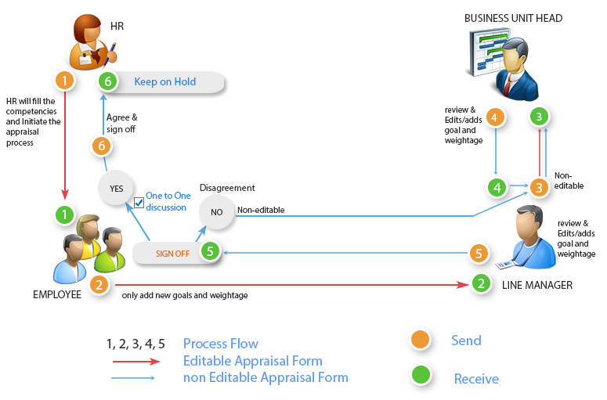

2) **Appraisal Self Assessment:**

**i) Add/Edit Goals:**

* The goal which is assigned and initiate by HR will come here for Employee approval.
* Here Employee can add goals for himself which will also go for approval as shown in the above flowchart.

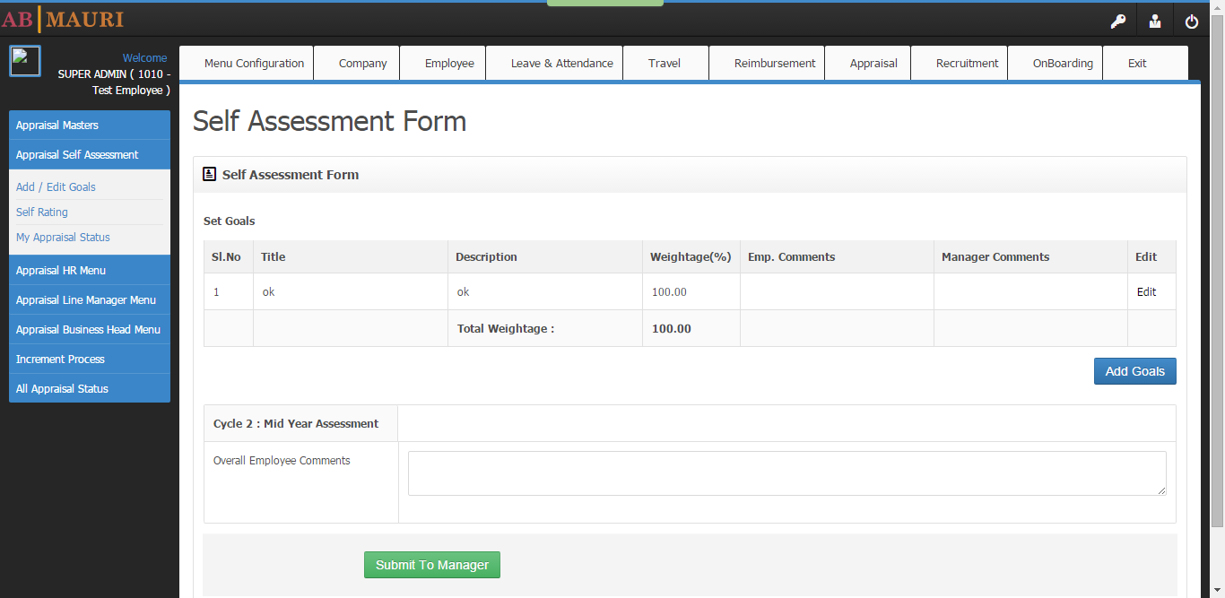

**ii) Self Rating:** Afterthe Goal process the rating cycle will start end first it will come here to employee login for self rating which will again go for approval and approver’s rating.

**iii) My Appraisal Status:** In the whole appraisal process the status can be seen by employee here.

**3. Appraisal HR Menu:**

**i) Initiate Goals I:**

* After adding goals for particular Employee HR needs to initiate the process for the same employee here.

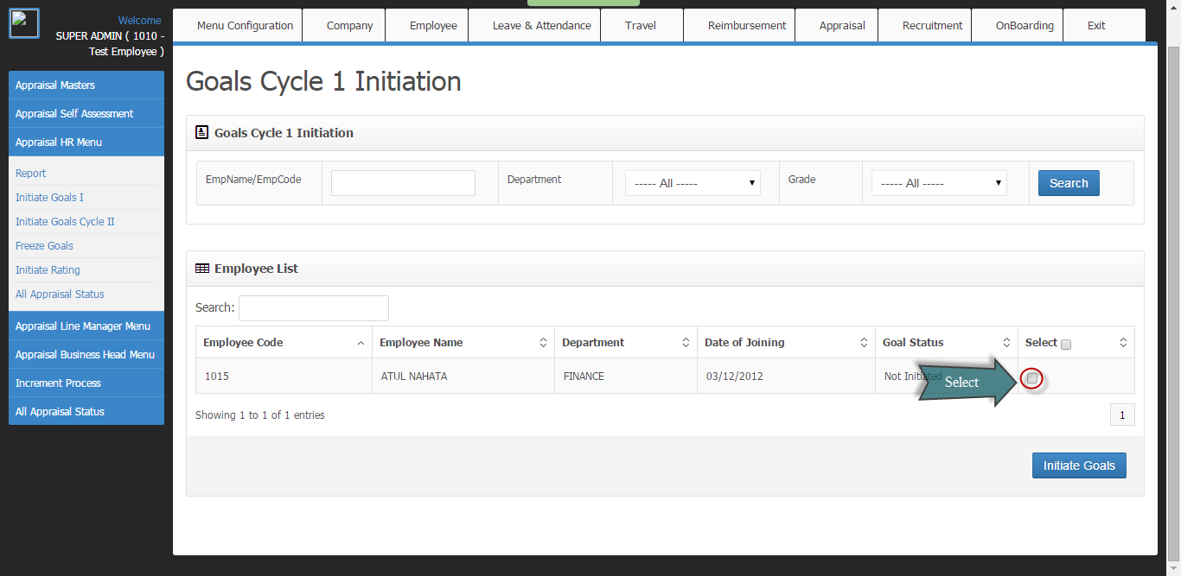

* HR needs to select the red circled field and click on Initiate Goals initiate the goal cycle for the particular employee.
* From this menu the goal will be moved to Employee’s **Add/Edit Goals** menu.

**ii) Initiate Goals Cycle II:**

* After completion of first cycle the2nd goal cycle will start which will be initiated by the HR from here.
* The total weightage of goals of Cycle 1 and 2 should be 100.
* If that will not maintain system won’t allow the user to submit the form.
* After the goal cycle will move to approver’s menu the weightage will be 100.
* So if the approver wants to add some goals they need to add the previous goals ,and lower the weightage of other goals to add new goal. But in any place of time sum of total weightage has to be 100.
* So finally based on this weightage approver will rate the employee.

**Iii) Freeze Goals:** After completion of both the goal cycle finally the status will come to this tab for HR to freeze the goals. The page will moved to **initiate Rating.**

**iv) Initiate Rating:** After the completion of goal cycle, rating cycle will be initiated by the HR from here which will again move to the employees menu for self rating.

**v) All Appraisal Status:**

* The status of each and every employee those who are in appraisal cycle can be seen here which will be visible like the below image.
* Goal Status, Rating status, Increment status can be seen here with appraisal and increment view.
* At any point of time if HR wants to re-initiate the appraisal process for any particular employee, he can delete the process here and start a new process for the same.
* This authority has been given to HR only. Except him no one can delete the ongoing process at any point of time.

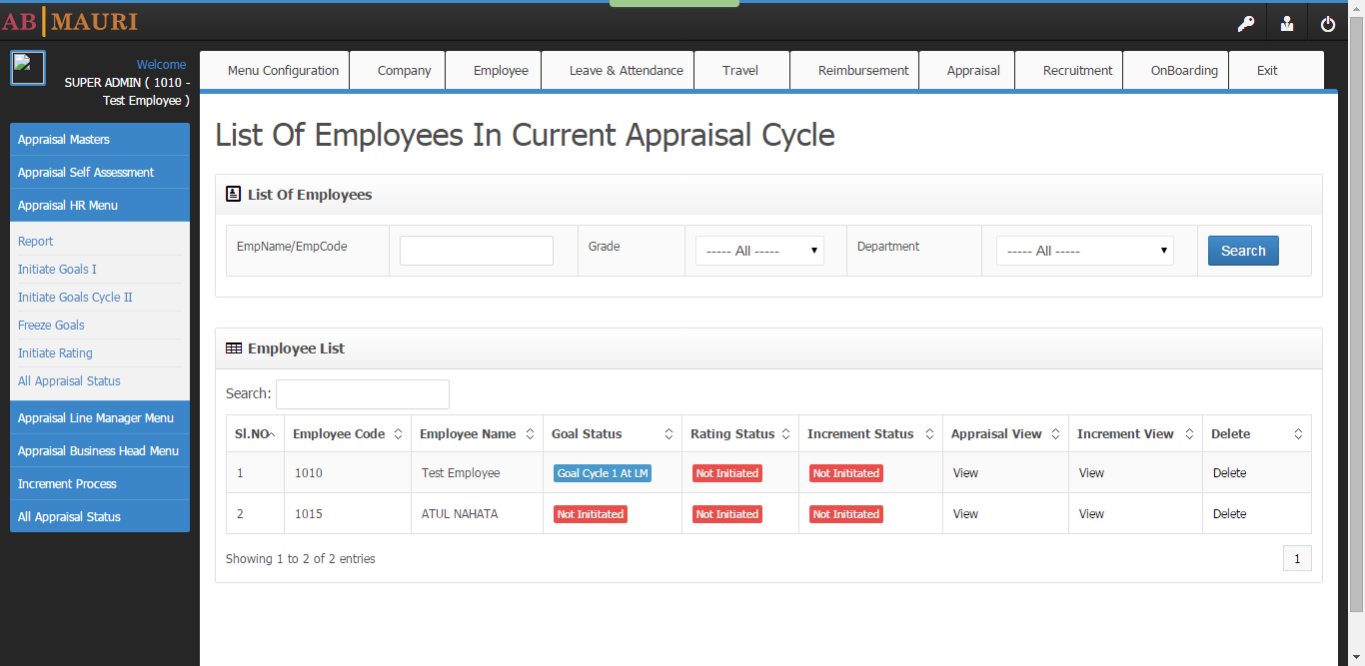

**vi) Report:** The report for all the appraisal process initiated can be generated from here.

**4. Appraisal Line Manager Menu:**

**i)Review Goal As LM:**

* The goals which are assigned to employees by HR and himself will come to this tab for approval first .If approver wants to add goals they can click on Add Goals or else can edit goals by clicking on Edit as shown in the below image.
* Now if LM will be satisfied with the goal for the present cycle he can approve it by clicking on and the page will be moved to BH’s tab.

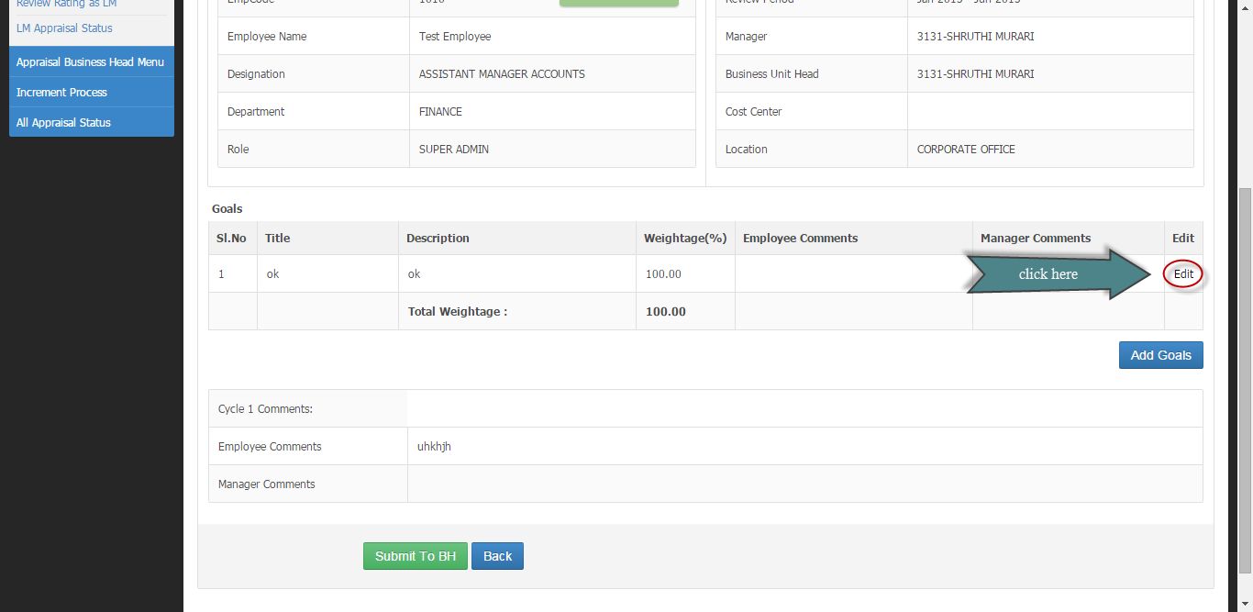

**ii) Review Rating as LM:**

* After employee sends the rating cycle for approval from **Self Rating** menu it will come to this menu for approval.
* So here approver will rate the particular employee according to the goal assigned and the weightage provided.
* After completing the rating followed by clicking submit, the system will calculate the weighted average.

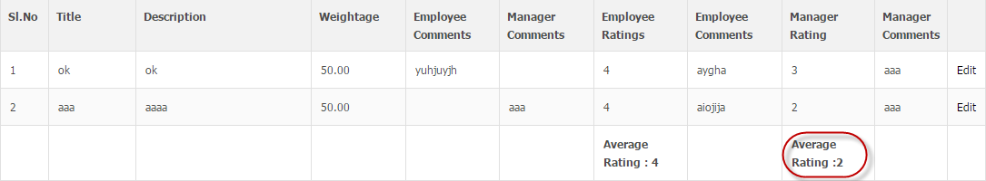

* Rating system will work according to this average as shown below.

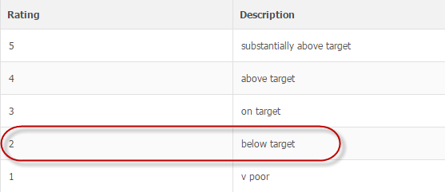

* Now according to the description LM has to choose the preferred color the employee deserves which shown in below image.

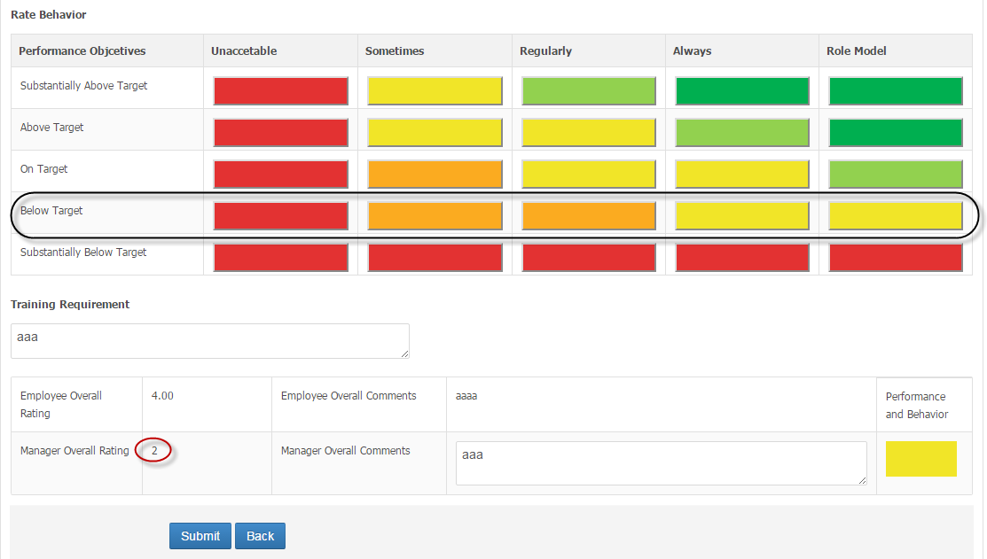

* As shown in the above image the black circled area is got activated in the color pattern depending on the manager’s overall rating.
* Now after clicking submit the form will moved to BH’s approval tab for further process.

**iii) LM Appraisal status:** All the status of approval come to LM’s menu can be seen here.

**5. Appraisal Business Head Menu:**

**All the process are same as the LM menu.**

**The exceptions are**

1. After approval the form will again go to LM to complete the process as shown in the flow chart.
2. Then after BH’s approval the goals will moved to Employee’s login.
3. If he is satisfied with all the changes made by BH and LM, he will submit it and the form will go to HR’s menu in **Initiate Goal cycle II** (same as goal cycle I) after which the page will come to **Freeze Goals**.
4. Now HR can Initiate the Rating cycle after Freezing the goals which will again come for LM’s approval and after that to BH’s approval and the same process will follow as goal cycle as shown in the below image.
5. Finally the rating will come to HR tab and he will initiate the increment process.

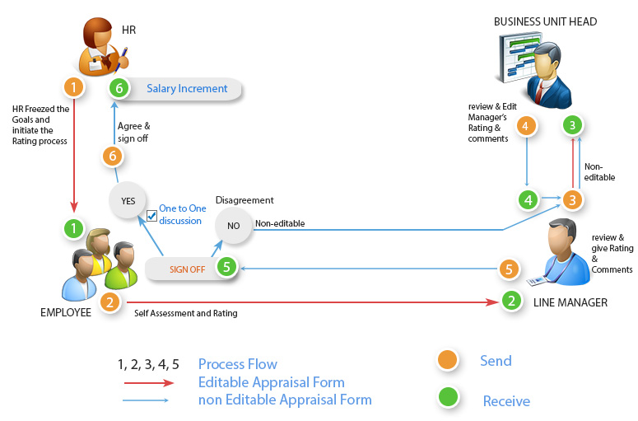

**6. Increment Process:**

**i)Initiate Increment:**

* After the successful submission rating cycle increment process has to be initiated by the HR for the particular employee from here.
* Here for initiating increment cycle HR needs to click on View as shown in the below image.

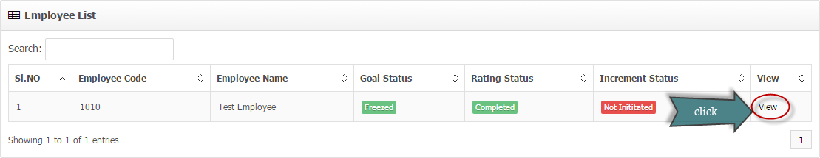

* It will redirect to the following page in which increment details are present for reference along with the form in which current increment details has to enter according to the rating shown below.

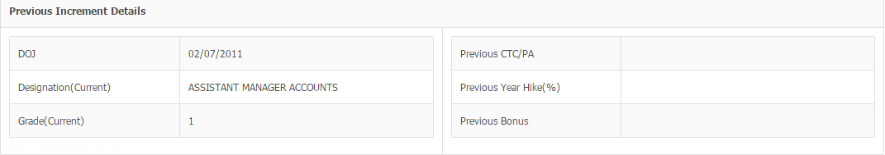

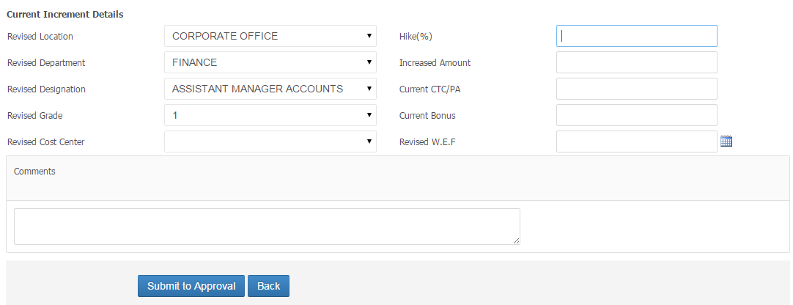

* After completing the form HR has to submit it for approval to HR-BP and MD at the same time.

**ii)Approve Increment As HR-BP:**

* The increment form will come to both HR-BP and MD at the same time.
* So to complete the process both the approver needs to approve the form.
* If any one of the approver will reject, it will go back to HR.
* At the time of rejection the approver has to mention some comments based on which the HR will make the changes in the increment form and sends it back for approval.
* After the approval of both the approver the appraisal process will be closed and it can be seen in all appraisal status.

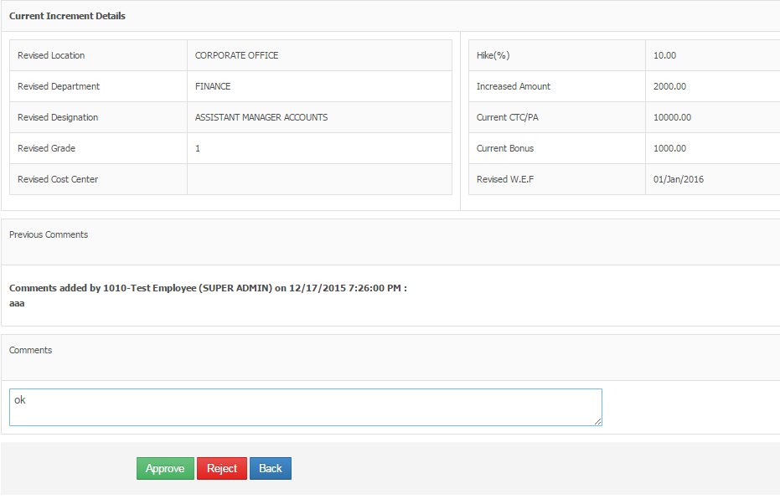

**iii) Approved Increment as MD:** The same process has to follow here.

**7. All Appraisal status:** Already explained in **Appraisal Hr Menu.**

**Recruitment:**

**1. Recruitment master:** It contains all the master data which are going to use in the **Recruitment process.** This menu will be available

**2. Requisition from:**

* This is the first step of recruitment process.
* This menu is given to who will Line Manger initiate the Recruitment process by creating the RRF which is otherwise known as Recruitment Requisition form.
* After filling the form followed by clicking submit, it will move to business head’s profile for approval.
* The process of approval is explained in the below image.

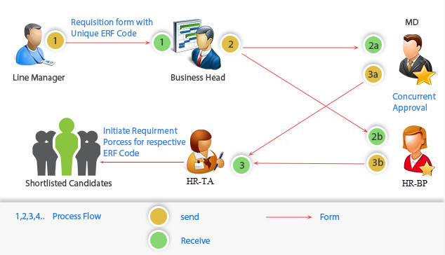

* After the approval of business head the form will move to **MD** and **HR-BP** simultaneously(as 2a and 2b)
* Then after getting approval by both **MD** and **HR-BP** the form will move to **HR-TA** who willinitiate the recruitment process.
* The status of RRF can be seen in **RRF Status.**

**3. Approve RRF:** As explained in **Requisition form**.

i) To approve the RRF approvers needs to click below the view column on the required RRF number as shown in the below image.

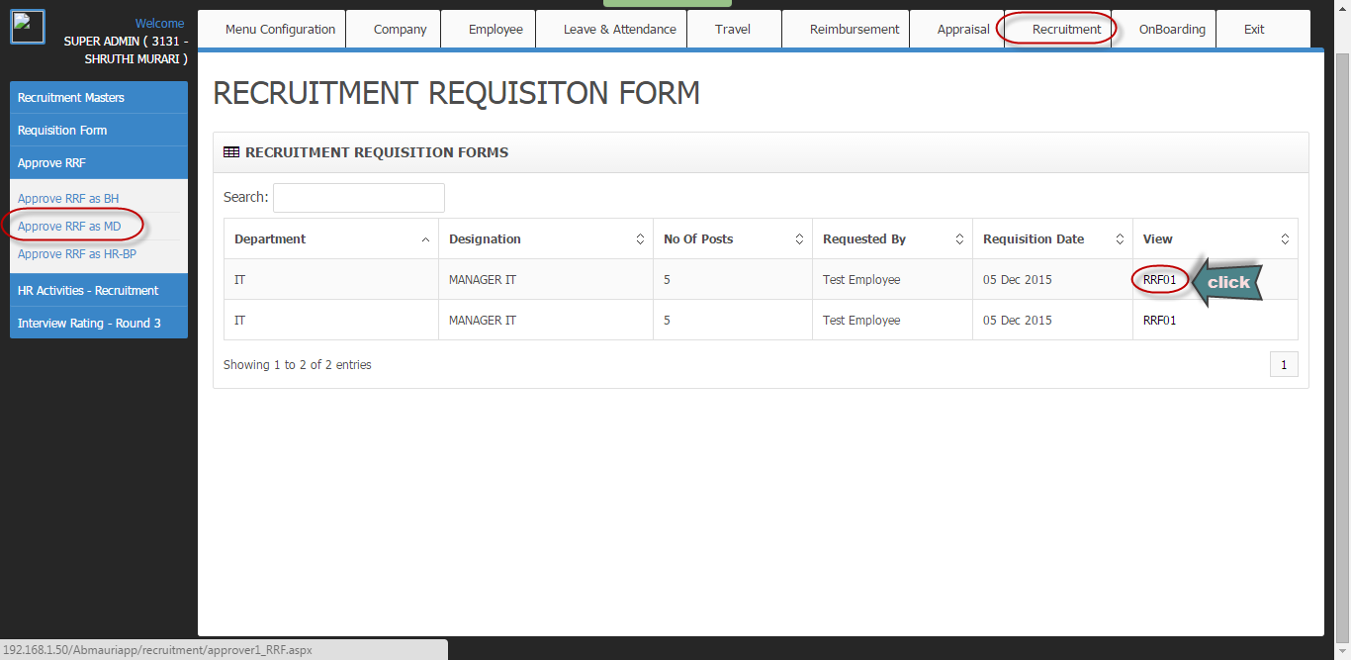

ii) After that a page will come with all the information of that RRF and approver have to read that information and write the comment(if any) followed by clicking on Approve.

**4. HR Activities:**

This menu will be given to HR-TA who will complete the Recruitment process.

i) **Initiate Recruitment:**

* The RRF which approved by all the three approver will move to this menu.
* HR needs to select the preferred RRF followed by clicking on Initiate Recruitment.

ii) **Consultancies and Employee Referral:** In this tab the candidates which are referred by employees and consultancies can be seen and moved for interview process.

iii) **Candidate Registration Form:** Here HR can register candidates by filling their details for further recruitment process.

iv) **Search Resume:**

* The candidates those who areregistered through referral or registration process can be seen in this tab. HR can search for preferred candidates by three parameters a) skill name,

b) Experience,

c) Expected salary.

* From here HR can push the candidates profile for interview process by selecting RRF no from drop down and preferred candidate for the same RRF.

v) **Assign Interview panel:** Before starting the interview process HR needs to assign interview panel for the final round of recruitment process.

vi)**Round One Candidates:** The candidates those are pushed from search resume will come to this tab and after completing the first round HR needs to update whether the candidate is moved to next round or rejected.

v) **Round Two Candidates:** The same process has to follow as Round one.

vi)**Round Three Candidates:**

* The candidate those are selected in round two can be seen here.
* The system will send those candidates profiles to the panel which is assigned previously.
* After the panel’s update the final set of candidates will come in this tab.
* Now HR can update the final result of the interview process by selecting or rejecting the candidate profile based on panel’s comment.

vii) **Final Confirmed And Rejected Candidates:** Here by selecting the RRF no HR can able to see the list of candidates who are selected and rejected.

viii) **Close Vacancy**: After completion of the recruitment process for a particular vacancy it needs to close, which can be done here.

ix) **Put RRF On Hold**:

* If for any reason there is a need of putting hold on the recruitment process, HR can do it here.
* In this case after putting on hold the RRF can’t be seen anywhere in the recruitment process until and unless the same RRF will be unhold.

x) **RRF History:** All the details regarding RRF can be seen here. Please follow the below image.

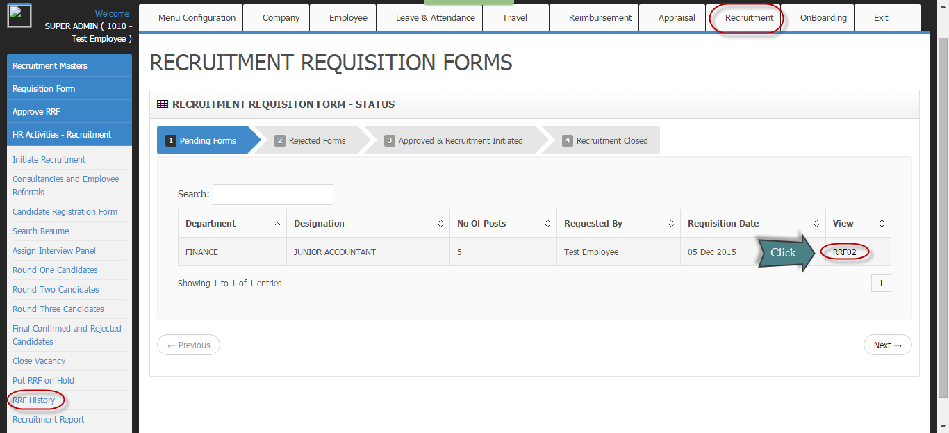

Xi) **Recruitment Report:** All the reports regarding the complete recruitment process can be generated here.

**5. Interview Rating –Round 3:**

* This menu will be given to the panelist of 3rd round as assigned in **HR activities>Assign Interview Panel.**
* After the completion of 2nd round the selected candidate profiles will be pushed for the third round here.
* After the completion of 3rd round again the profile will be forwarded to HR which can be seen in “**Round Three Candidates**”.

**OnBoarding:**

**1. New Employee Creation:**

**i) Create New Employee Login:**

* Whenever a new employee will join the profile creation start from here.
* First for employee login username and password has to create here by providing valid credentials.
* Employee code which is previously existed can’t be given here.

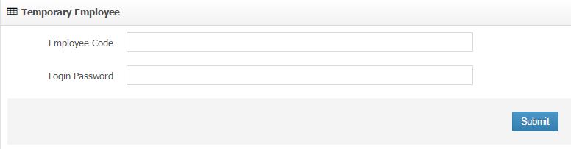

* Then by using this username password new employee has to log in to his account and he will get only the EDB tab in which he has to fill all the details he has and finally can click on update in last page.
* As soon as he will click on update there will be no menu on his profile and the details will move to **Validate New Employee details** tab.

ii) **Validate New Employee details:**

* Now HR needs to validate all the details provided by the employee and complete all the mandatory fields to submit the employee details and add him to Employee Archive.

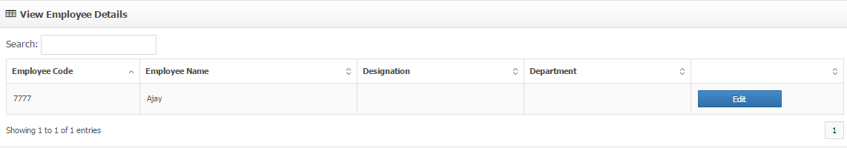

* This menu will be visible so HR can edit the details by clicking on Edit button and finally click on Approve in last page.
* Once done the role by default will be assigned as “user” later the relevant role can be assigned in “view edit employee” in EDB by Super admin.

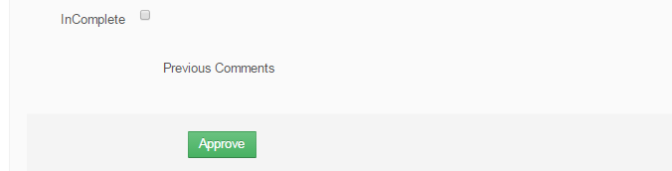

* There is a check box named as Incomplete. So if the details will not fully covered than by clicking on the Check box a comment box will appear as shown in the below image

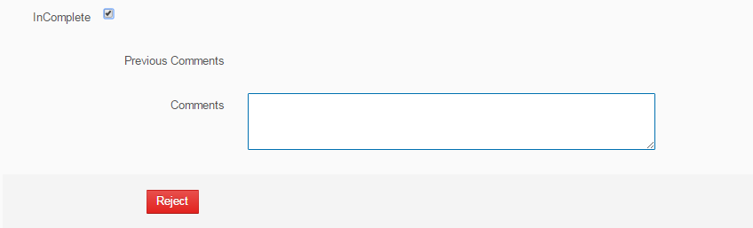

* So by giving the details what has to be done in the comment box HR can reject the form.

**2. OnBoarding Forms:**

* In this tab there are some dynamic form templates has been created as shown below.

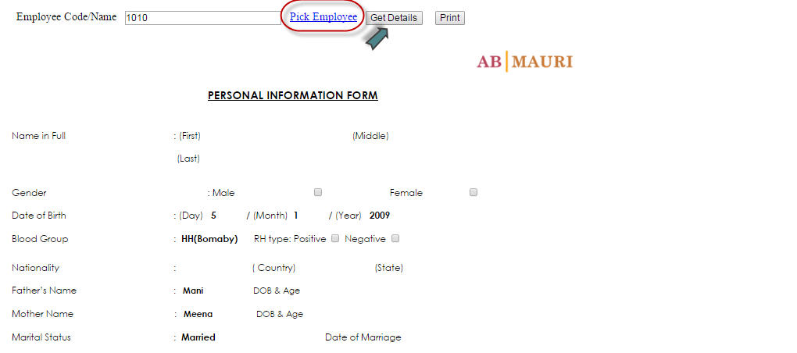

* To work with this template User has to choose the employee by clicking on **Pick Employee** followed by clicking **Get Details**.
* The details those are available in the EDB will be populated automatically.
* Then there is a **Print** button by clicking which the form will move for printing.
* The forms are I. Personal Information Form

II. Bank Details Form

III. Induction Complete Form

IV. Insurance Nomination Form

V. VPF Declaration Form

VI. Food Coupons Declaration Form

VII. Generate All Forms

**Exit:**

1. **Resignation:**

**i)Raise Resignation Request:** Any employee wants to resign can edit his credentials in the comment box and send it for further approval by clicking on

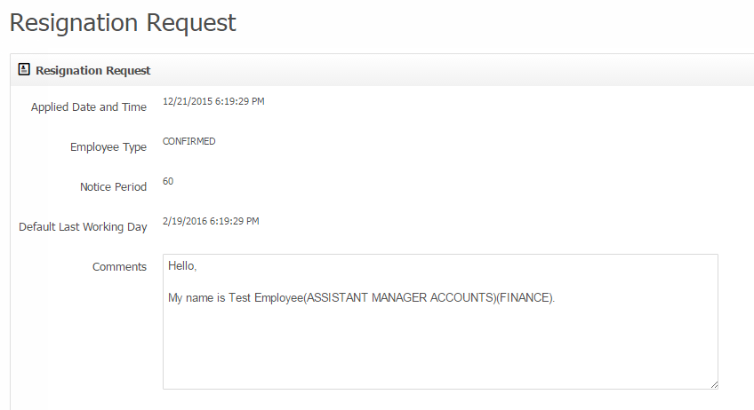

**II) Pending Resignation Request:** After the submission of resignation form until and unless all the approval approved, it will stay in this tab.

**III) Rejected Resignation Request:** If the Resignation form is got rejected then it will move to this tab.

**IV) Approved Resignation Request:** If all the approval process is successfully complete then the form can be seen in this tab.

1. **Approve Resignations:**
2. **Pending Resignation Request:**

* When any employee will apply for resignation it will first move to his Line Manager and BH for approval.
* Here approver can edit the default last working day if required as shown in below image.
* They can write some comment in the comment box followed by clicking on approve or reject.
* After the approval process the form will go to **Exit Process** menu which has been given to HR and then the exit process will start.
* If the application will be rejected then the form will go back to the employee.

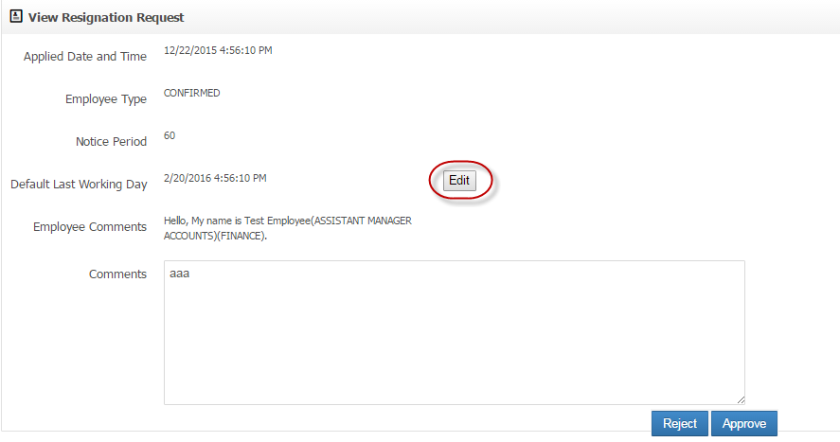

1. **Approved Resignation Status:**

If the application is approved by both the approver the status can be seen here.

1. **Rejected Resignation Status:**

If the application got rejected by any one of the approver it will come to here.

1. **Exit Process:**

**This process will be handled by HR**

1. **Initiate Exit:**

* From this tab HR can initiate the Exit process for approved employee.
* He will get a page as shown below for each employee.
* By selecting the particular employee and HR has to click on View.

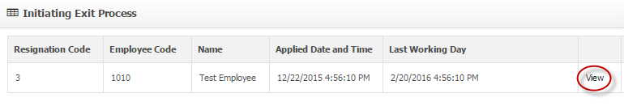

* Again HR will redirect to a page where he can edit the default last working day by clicking on Edit button as shown in below image.
* He can provide some comment in the comment box.
* Finally by clicking on Initiate Exit Process the application will moved to **Pending Clearance** in **Exit clearance** menu for approval.

1. **Exit Clearance Status:** After the Exit process will start HR can see the status here.
2. **Rejected Resignation Status:** If any of the clearance approver will reject the application it will come in Rejected resignation status.
3. **Approved Resignation Status:** If the application will get clearance by the entire 6 department,it can be seen here.
4. **Exit Clearance:**
5. **Pending Clearance:**

**This menu will be given to all the approvers those are involved in this process.**

**Below are the approvers to whom the approval form will go.**

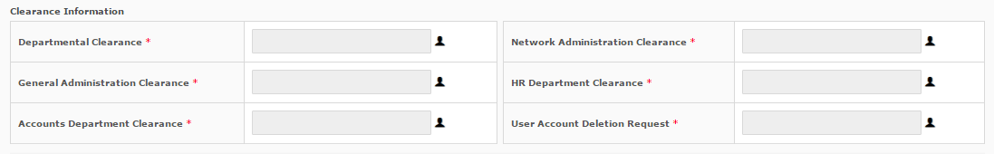

* As soon as Exit Process will start all the approvers for the particular employee will get the application here at the same time.
* If for 1 approver multiple clearance option is given it will be seen as below.

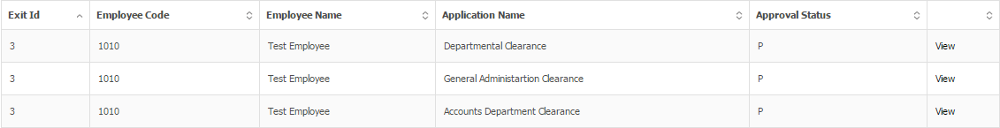

* Here there are in total 6 departments

a) Departmental Clearance

b) General Administration Clearance

c) Accounts Department Clearance

d) It and Network Clearance Form

e) User Account Deletion Request

f) HR Department Clearance

**II) Clearance Status:** At any point of clearance process the status can be seen in this tab.

1. **Resigned List:**

As soon as the clearance process is completed the employee will move to **Resigned list.**

1. **Download:** Form required for Exit process can be downloaded here**.**